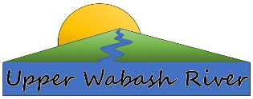
Upper Wabash
River Watershed
Cost-Share Program

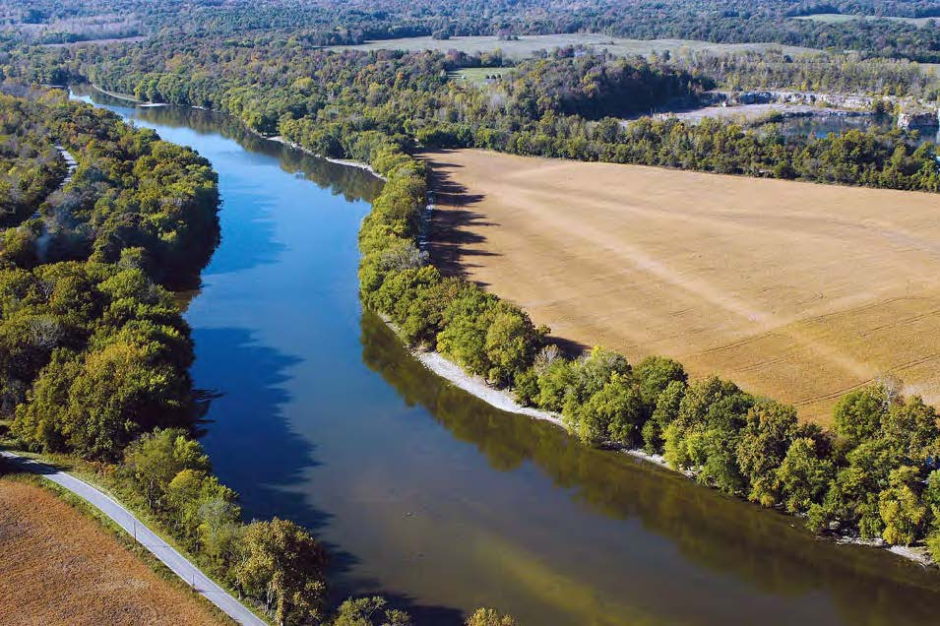

Funded by a Federal 319 Grant through the Indiana Department of Environmental Management and by Watershed Partners
Created by Huntington County Soil and
Water Conservation District
Grant # 58551

Executive Document Summary
In April of 2018, the Indiana Department of Environmental Management (IDEM) awarded the Huntington County SWCD a Clean Water Act Section 205j Grant. The funds ($138,200) were utilized to develop the Upper Wabash River (UWR) Phase III Watershed Management Plan (WMP) which included water quality monitoring and education and outreach programs.
The Huntington County SWCD and conservation partners completed the UWR Watershed Management Plan in June of 2021. Information acquired through a detailed watershed assessment was used to create the UWR Watershed Management Plan. This information revealed water quality issues associated with excess nutrients, sediments, and E.coli throughout four 10-digit HUCs (0512010110. Aboite Creek-Little River, 0512010112, Clear Creek, 0512010111, Little River and 0512010113, Loon Creek-Wabash River). A comprehensive scoring system was used to identify priority sub-watersheds and were ranked according to their contributions to non-point source (NPS) pollution throughout the UWR Watershed. A point system was used to rank each of the HUC12 watersheds. Tier 1 as being primary critical areas, Tier 2 as secondary critical areas and Tier 3 as non-critical areas. The Tier 1 sub-watershed areas showed the greatest need for implementation of BMPs and will greatly benefit the quality of water quality in our rivers in streams.

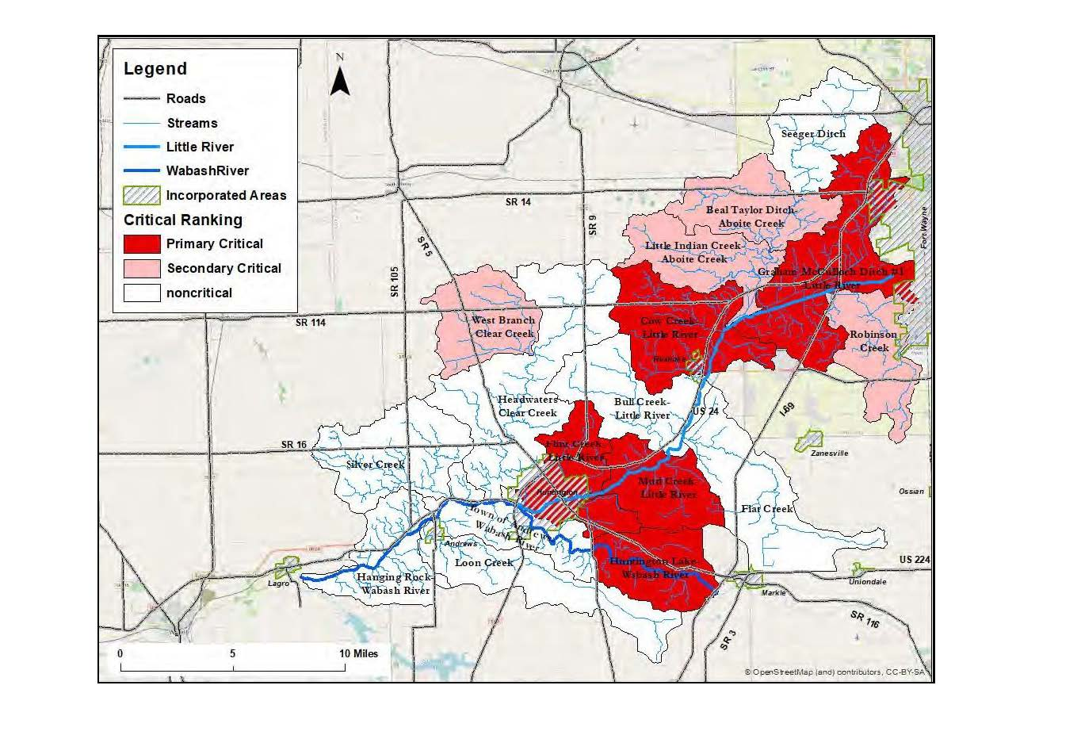
This cost-share program has been developed to guide the implementation of the Upper Wabash River (UWR) watershed management plan. Land-use in the UWR watershed is predominately agriculture (nearly 70%), which can lead to high levels of NPS pollution such as nitrogen and phosphorous, excess sediment and E. coli contamination. Sub-watersheds with the greatest need for conservation practices were identified in the UWR Watershed Management Plan. To help guide the implementation of the cost share plan in the UWR watershed, HUC12 watersheds were designated as either Primary Critical (Tier1), Secondary Critical (Tier 2) and Non-Critical (Tier 3) areas (Figure 1). Critical areas can be found in section 5.2, pg. 246-250 of the watershed management plan. Critical areas were evaluated according to their relative contribution to the issues stated above. Non-critical (Tier 3) watersheds are in the best condition, and are a lower priority, while Secondary Critical (Tier 2) watersheds are in intermediate condition. Primary Critical (Tier 1) watersheds are described as the most degraded and are a high priority for implementation of BMPs. This cost-share program will target Primary Critical (Tier 1) watersheds where implementation dollars are expected to have the most notable impact on conservation (Table 1; Figures 2-9). However, watersheds in all three tiers may benefit from BMPs to improve water quality and protect and enhance existing natural resources. Secondary Critical (Tier 2) areas will be considered for cost-share implementation if all efforts in Primary Critical (Tier 1) sub-watersheds are exhausted and funds remain.

Figure 1. Critical Areas in the Upper Wabash River (UWR) Watershed
Table 1. Target watersheds designated as Primary Critical (Tier 1).
HUC 12 | HUC 12 Name | Acres | % of total Tier 1 area
51201011004 | Graham McColloch Ditch #1-Little River | 22,438 | 32.5
51201011301 | Huntington Lake-Wabash River | 10,231 | 14.82
51201011104 | Flint Creek-Little River | 10,850 | 15.71
51201011103 | Mud Creek-Little River | 10,043 | 14.54
51201011006 | Cow Creek-Little River | 15,487 | 22.43
 | Total | 69,049 | 100

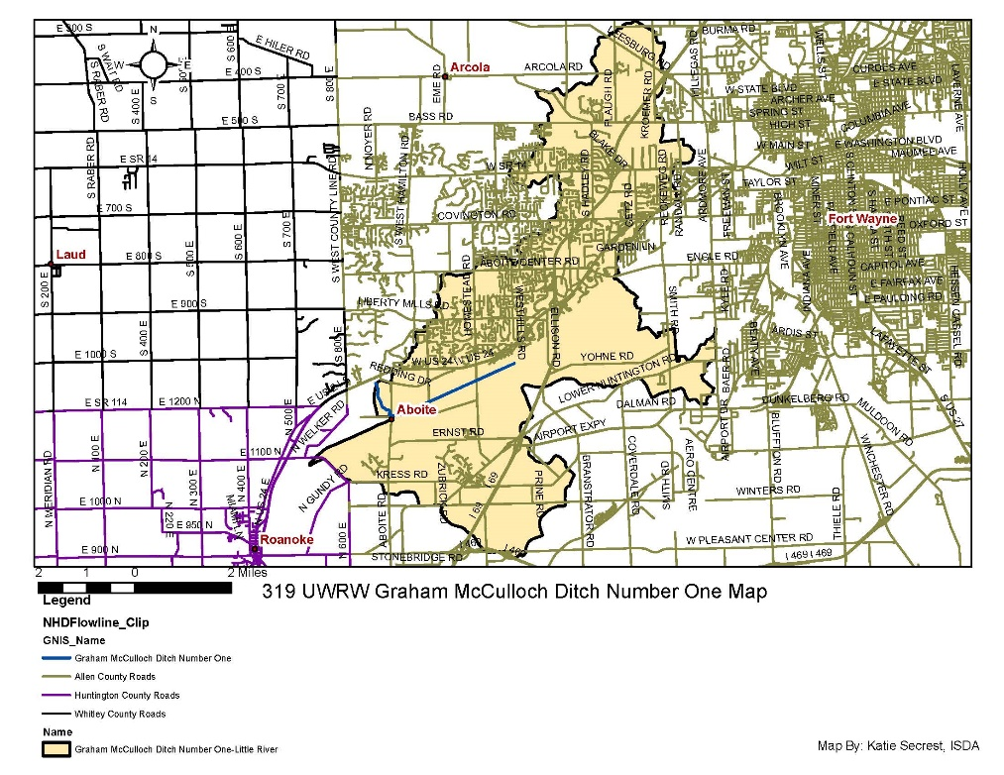
Graham McColloch Ditch #1-Little River: The Graham McColloch Ditch #1-Little River watershed (Figure 2) covers approximately 22,438 acres and contains 72.07 miles of streams (WMP pg. 135). During development of the UWR WMP, nutrient and sediment loading from the Graham McColloch Ditch #1-Little River watershed totaled 87.91 tons of nitrogen, 7.39 tons of phosphorous, and 712.93 tons of sediment per year (WMP pages 240-242). There are Fifty-nine (59) National Pollutant Discharge Elimination System (NPDES) facilities and Twenty-one (21) Leaking Underground Storage Tanks (LUST’s) (WMP pages 138-140) located within the watershed.

Figure 2. Graham McCulloch Ditch #1- Tier 1 Critical Watershed

Cow Creek-Little River: Cow Creek watershed (Figure 3) covers approximately 15,487 acres and contains 47.44 miles of streams (WMP pgs. 153-154) During development of the UWR WMP, nutrient and sediment loading from the Cow Creek-Little River watershed totaled approximately 25.03 tons of nitrogen, 12.35 tons of phosphorous, and 988.65 tons of sediment per year (WMP pgs. 240-242). There are eight (8) LUST’s, one (1) Brownfield and ten (10) NPDES facilities (WMP pg. 153, 155-156) located within the watershed. Segments listed on the 303(d) list of impaired waters in Mud Creek include: Aboite Creek (segment ID: INB01A5_05) - impairment for this 2.98-mile reach is E. coli. Little River (segment INB01A6_02) - impairments for this 5.1-mile reach include E. coli and Impaired Biotic Communities. Calf Creek (segment ID: INB01A6_T1002) – impairments for this 15.84-mile reach include E. coli and Impaired Biotic Communities (WMP pg. 65)

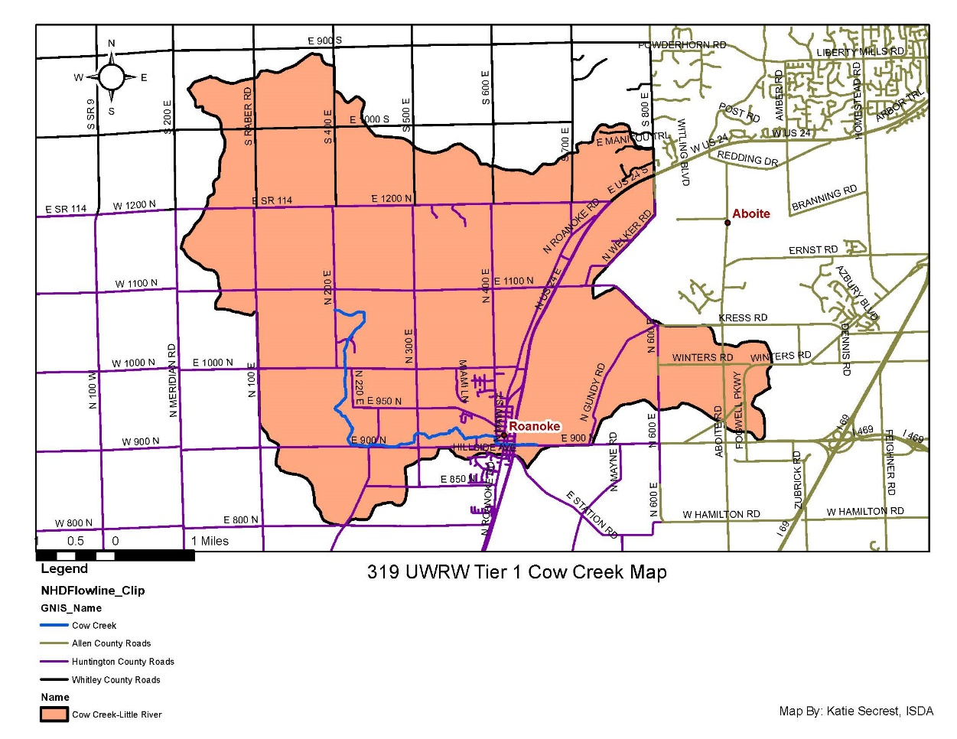

Figure 3. Cow Creek-Little River - Tier 1 Critical Watershed

Mud Creek: The Mud Creek watershed (Figure 4) covers approximately 10,042.98 acres and contains 20.92 miles of streams (WMP pg. 192) During development of the UWR WMP, nutrient and sediment loading from the Mud Creek watershed totaled approximately 172.35 tons of nitrogen, 663.75 tons of sediment per year. Phosphorous levels were at a minus -11.99 (low stream levels affected sampling) (WMP pgs. 240-242). There is one (1) Brownfield, one (1) Confined Feeding Operation (CFO) and six (6) NPDES facilities (WMP pg. 191 in the Mud Creek Watershed. Segments listed on the 303(d) list of impaired waters in Mud Creek include: Little River (segment ID: INB01B3_01) - impairments for this 4.41-mile reach include E. coli and Nutrients. Mud Creek (segment INB01B3_T1001) - impairments for this 7.71-mile reach include E. coli and Impaired Biotic Communities (WMP pg. 65)
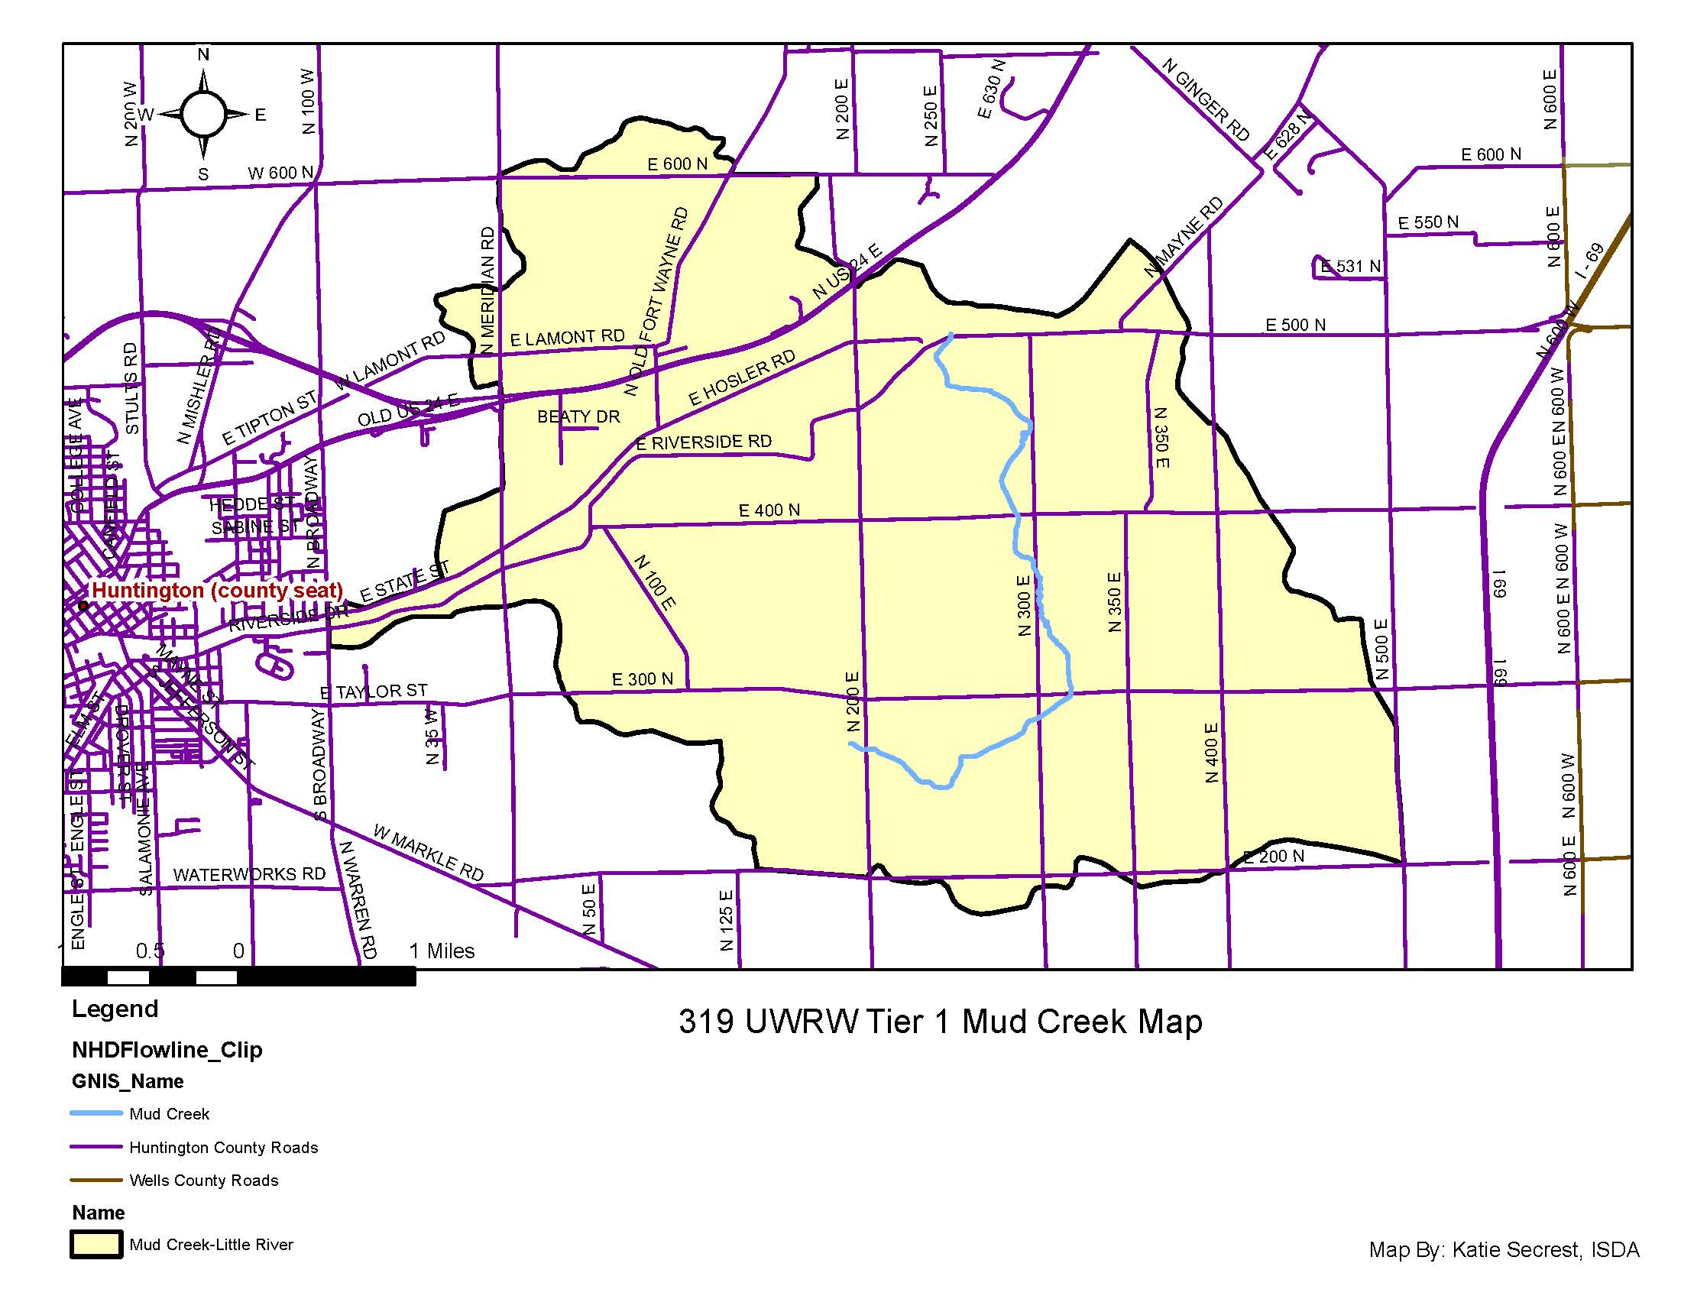

Figure 4. Mud Creek-Little River - Tier 1 Critical Watershed

Huntington Lake-Wabash River: The Huntington Lake-Wabash River watershed (Figure 5) covers approximately 10,231 acres and contains 21.27 miles of streams (WMP pgs. 195-196) During development of the UWR WMP, nutrient and sediment loading from the Huntington Lake-Wabash River watershed totaled approximately 2,798.19 tons of nitrogen, 54.46 tons of phosphorous, and 42,435.07 tons of sediment per year (WMP pgs. 240-242). There is one (1) NPDES facility (WMP pg. 197) located within the watershed. Wabash River (segment ID: INB01D3_01) is listed on the 303(d) list of impaired waters. Impairments for this 13.35-mile reach include Impaired Biotic Communities, polychlorinated biphenyls (PCBs) in fish tissue. Impairments for Huntington Lake (segment ID: INB01P1008_00) 900 acres and Rock Creek (segment ID: INB0174_02) 1.95-mile reach include polychlorinated biphenyls (PCBs) in fish tissue. (WMP pg. 65)

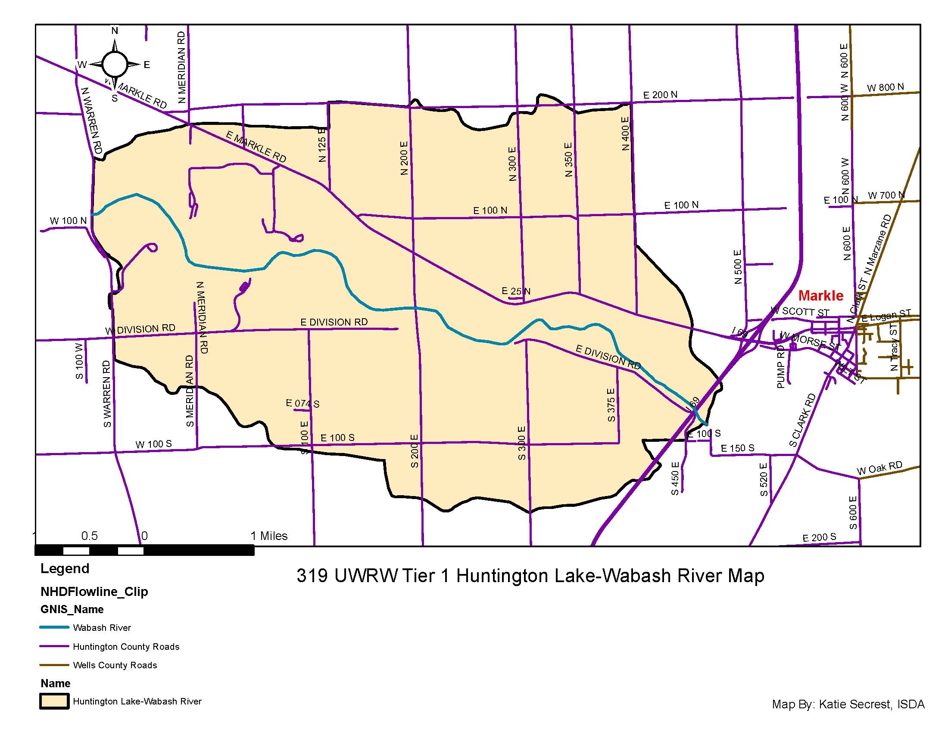

Figure 5. Huntington Lake-Wabash River- Tier 1 Critical Watershed

Flint Creek-Little River: The Flint Creek-Little River watershed (Figure 6) covers approximately 10,850 acres and contains 18.74 miles of streams (WMP pgs. 175-176). During development of the UWR WMP, nutrient and sediment loading from the Flint Creek-Little River watershed totaled approximately 475.49 tons of nitrogen, 26.97 tons of phosphorous, and 9,522.95 tons of sediment per year (WMP pgs. 240-242). There are nineteen (19) NPDES facilities, fourteen (14) CSO’s, twenty-eight (28) LUST’s and six (6) brownfields (WMP pgs. 179-180) located within the Flint Creek watershed.

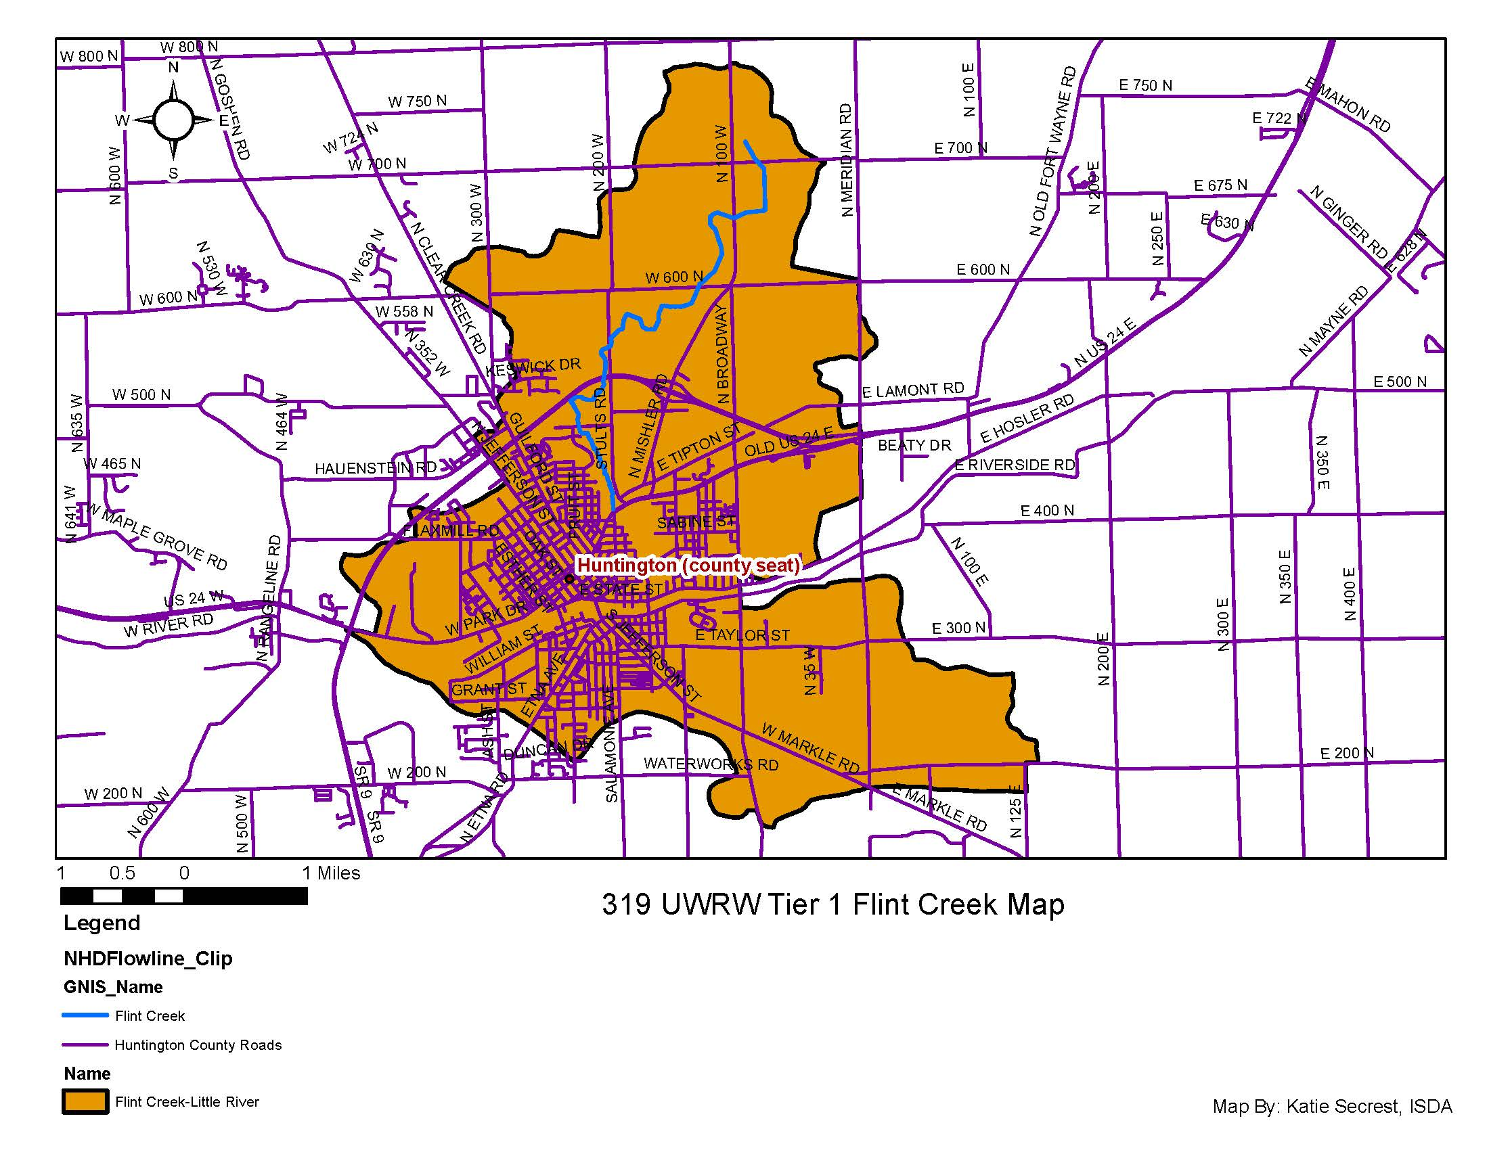

Figure 6. Flint Creek- Tier 1 Critical Watershed

Land-use in the UWR watershed area is nearly 70 percent agricultural, which includes row-crops, pasture/hay, and livestock operations. Due to the high percentage of agricultural acres throughout the watershed, local farmers and producers will be the target for this cost-share program. Developed areas, which are the second highest land use in the watershed, will be a priority as well in promoting the implementation of BMPs. Property owners in Tier 1 watersheds will be the focus for implementation funds. Eligible best management practices (BMPs) were selected based on conservation needs, such as reducing sediment, nutrient, and E. coli contamination in local waterways, as well as cost to pollutant load reduction ratio, and likelihood of landowner acceptance as determined by the UWR watershed steering committee. Eligible BMPs were ranked 1 through 5 representing a gradient of high to low priority for UWSR watershed cost-share dollars and are listed in Table 2.

Table 2. Eligible Best Management Practices (BMPs) for Cost-Share in UWR Watershed
NRCS Conservation Practice Codes | Conservation Practice | Target Pollutant | Average Costs Guide and Practice Caps | Priority for UWR Watershed Cost-Share Dollars
340 | Cover Crop | Sediment, Nutrients | $20/Acre single species; $35/acre multiple species ($9,000 cap) | 1
393 | Filter Strip | Sediment, Nutrients | Approx. $474.15/Acre (Varies) | 1
329, 345, 585, 590 | Equipment Modification (Conservation Tillage, Cover Crops, Strip Cropping and/or Precision Nutrient Application) | Sediment, Nutrients | Varies ($5,000 Cap) | 1
329 | Residue and Tillage Management No-Till/Strip Till | Sediment, Nutrients | $17.07/Acre | 1
345 | Residue and Tillage Management Reduced Till | Sediment, Nutrients | $15.96/Acre | 1
590 | Nutrient Management | Sediment, Nutrients, E. coli | Varies $6.53/Acre; $13.86/Acre (with Manure) | 1
412,484 | Grassed Waterway (Mulching if Necessary) | Sediment, Nutrients | Varies with width $3,277-$4,024/Acre, Mulching- Varies $297-$7,538/Acre | 1
342 | Critical Area Planting | Sediment, Nutrients | Varies $175.63-$435.08/Acre | 2
638, 606 | Water and Sediment Control Basin with Subsurface Drain | Sediment, Nutrients, E. coli | $2.64/CuYd, Subsurface Drain- Varies with size. $1.94-$10.23/foot | 2
390 | Riparian Herbaceous Cover | Sediment, Nutrients | Approx. $452.29/Acre | 2
512 | Pasture and Hay Planting | Sediment, Nutrients | Varies $126.45-$371.33/Acre | 2
472 | Access Control: Animal Exclusion from Sensitive Areas | Sediment, Nutrients, E. coli | $51.44/Acre | 3
614 | Watering Facility (Permanent) | Sediment, Nutrients, E. coli | $1,002.88 | 3
382 | Fence | Sediment, Nutrients, E. coli | $1.65/foot | 3
561 | Heavy Use Area Protection | Sediment, Nutrients, E. coli | $1.13/sq. foot | 3
391 | Riparian Forest Buffer | Sediment, Nutrients | $1,013.76/Acre | 4
528 | Prescribed Grazing | Sediment, Nutrients, E. coli | Varies $21.55-$45.80/Acre | 4
580 | Stream Bank and Shoreline Protection | Sediment, Nutrients | $44.36/foot  ($2,000 cap on urban practices) | 5
582 | Two Stage Ditch | Sediment, Nutrients | $8.79/foot ($32,000 Cap) | 5

Table 2. Cont. Eligible Best Management Practices (BMPs) for Cost-Share in UWR Watershed
NRCS Conservation Practice Codes | Conservation Practice | Target Pollutant | Average Costs Guide and Practice Caps | Priority for UWR Watershed Cost-Share Dollars
 | Rain Garden/Bioswales | Sediment, Nutrients, E.coli, Storm Water | $12/ft² up to $2,000 per garden | 1
 | Rain Barrel | Sediment, Nutrients, E.coli, Storm Water | $100 | 1
 | Porous (pervious) Pavement | Storm Water run-off, water quality | $10/ft² up to $2,000 | 1
 | Phosphorus-free Fertilizer | Nutrients | $1,000 | 1
 | Native/Prairie Plantings | Nutrients, Water Quality | $2,000; not to exceed $1,500 per acre | 1

Note: Other BMPs may be added to the approved list if they are found to be beneficial in the watershed, or if new practices are approved by IDEM during the cost-share program implementation

Maximum Cost-Share: Cost-share will not exceed 75% of the actual cost of the practice, with a cap no more than 75% of the average cost per NRCS guidelines (excluding tax). IDEM does not compensate at a flat rate per acre for best management practices. Landowners will be responsible for at least 25% of the cost-share practice cost.
Advertisement & Outreach: The Cost-Share program will be advertised through media releases, UWR watershed and SWCD newsletters, UWR watershed and SWCD websites, County SWCD and NRCS offices, Upper Wabash River Watershed Facebook page, word of mouth, public meetings, and other community events.
Review Process: Cost-share applications will be ranked by the SWCDs in cooperation with local NRCS and ISDA staff. Input will be obtained from the steering committee when necessary. A point system will be used for ranking and is included on the Ranking Form (Table 3). Each project is unique and site-specific conditions or situations may impact the final ranking of a project. In addition, priority will be given to projects in Tier 1 critical areas. Furthermore, cost-share funds will be divided among tier 1 sub-watersheds in proportion to their percentages of total tier 1 area in the UWR watershed (Table 1). Funds for projects will be allocated based on the scoring systems indicated in Table 3 until cost-share funds are exhausted. Applicants not funded through the project will be referred to other available cost-share programs if they are interested.
Administration of Cost-Share Program: The Upper Wabash River Watershed steering committee and the Huntington County SWCD will be responsible for the administration of the Cost-Share Program.
Funding Caps: For all projects, the maximum cost-share is 75% of actual cost or average costs, whichever is less. A $9,000 cap on any single practice, unless otherwise noted, with up to $20,000 cap for multiple practices per producer for the term of the grant will be implemented. There is a $9,000 cap on cover crops and $5,000 cap on equipment modifications. There are additionally caps for BMPs noted in Table 2, Eligible Best Management Practices (BMPs) for Cost-Share in UWR Watershed. These caps may be modified as necessary by the Technical Committee. One of the goals of the cost-share program is to leverage funds to help landowners who have never installed conservation practices to consider doing so. The committee will balance these considerations when making final funding decisions. Additionally, cost-share funds in Tier 1 critical areas will be prorated based on their proportions of all Tier 1 area in the UWR watershed (Table 1).
Field Equipment Modifications: Landowners operating within critical areas may apply for equipment modification cost-share funds that will allow for precision application of nutrients and/or conservation tillage. Maximum cost-share will be $5,000 for equipment modification. If equipment modification is for no-till, development of both a nutrient management plan and pest management plan are required. Additionally, if cost-share is for precision nutrient management, a nutrient management plan must be submitted.
Review and Approve BMPs: The Natural Resource Conservation Service (NRCS) Technical Team based in Huntington County has agreed to review and approve any BMPs installed under the Upper Wabash River Watershed Cost-Share Program to ensure that practices meet NRCS standards. The Tech Team will also work on engineering plans that may be necessary depending on the BMP to be installed. Payments will be made to landowners in arrears once approved BMPs have been installed and inspected. For equipment modifications, payment will be made once the equipment has been used to carry out the planned conservation activity.
All Agricultural BMPs will be installed based on NRCS standards.
Permits for BMPs: Any required permits will be the responsibility of the property owner where the practice will be applied.
Maintaining BMPs: The cost-share recipient will be responsible for the operation and maintenance of all BMPs. Maintenance of BMPs will follow IDEM standards such that vegetative practices shall be maintained for 5 years, with the exception of cover crops which will be maintained for 1 year, while structural BMPs will be maintained for 10 years.
Deadlines: The cost-share program ends when all cost-share funds have been allocated, or the deadline of October 15, 2024, has been reached. All landowners who have been approved for cost-share funding must have practices installed and their invoices delivered to the Huntington County SWCD on or before October 1, 2024. Applications for cost-share funds will be accepted no later than September 1, 2024.
Practice Geolocation: At a minimum, practices will be located via township, range section, or by a specified georeferenced point on a map.
Pollutant load reduction estimation: The Region 5 Load Estimation Model will be utilized to estimate pollutant load reductions associated with each installed BMP. Two-stage ditches do not require calculated load reductions. Rain barrels do not require load reductions, unless there are over 250 rain barrels installed.

Table 3. Upper Wabash River (UWR) Watershed Cost-Share Program Ranking Sheet
Written Conservation Plan Required | Yes | No | Maximum Possible Points | Actual Points
Watershed Criteria
Tier 1 Sub-watershed* (Cow Creek, Flint Creek, Graham McCulloch Ditch, Huntington Lake-Wabash River, Mud Creek) |  |  | If yes, proceed to BMP Ranking Criteria
Tier 2 Sub-watershed* (Beal Taylor Ditch, Little Indian Creek, Robinson Creek, West Branch Clear Creek)  Tier 3 Sub-watershed (Hanging Rock- Wabash River, Flat Creek, Head Waters Clear Creek, town of Andrews-Wabash River, Seegar Ditch, Bull Creek-Little River, Silver Creek, Loon Creek) | STOP HERE, NOT ELIGIBLE FOR COST-SHARE
*Please circle associated sub-watershed and provide location information below:
BMP Ranking Criteria
Priority Ranking 1 |  |  | 60
Priority Ranking 2 |  |  | 40
Priority Ranking 3 |  |  | 20
Priority Ranking 4 |  |  | 10
Priority Ranking 5 |  |  | 5
Location and Project Elements
Project Area: | Yes | No | Maximum Possible Points | Actual Points
Less than 500 feet from waterbody |  |  | 40
500 to 1000 feet from waterbody |  |  | 20
Greater than 1000 feet from waterbody |  |  | 10
Highly Erodible Soils:
Slopes 5% to 10% |  |  | 20
Slopes greater than 10% |  |  | 40
Not Highly Erodible, but serious erosion present |  |  | 20
Table 3 continued: Upper Wabash River Watershed Cost-Share Ranking Sheet
Cropland
Does the project convert cropland to permanent hay land, pasture, woodland, or wildlife habitat?
Slopes less than 5% |  |  | 10
Slopes 5% to 10% |  |  | 20
Slopes greater than 10% |  |  | 40
Does the project propose a conservation tillage system that leaves greater than 30% residue?
Slopes less than 5% |  |  | 10
Slopes 5% to 10% |  |  | 20
Slopes greater than 10% |  |  | 40
Cropland Continued
Does the project include using winter cover crops?
Slopes less than 5% |  |  | 10
Slopes 5% to 10% |  |  | 20
Slopes greater than 10% |  |  | 40
Does the project establish grass filter strips or herbaceous riparian buffers along streams on your farm?
30 foot width |  |  | 20
90 foot width |  |  | 40
Livestock
Does the project restrict livestock access to waterbodies?
Perennial or Intermittent Streams |  |  | 40
Other Waterbodies |  |  | 20
Does the project address a pasture with inadequate ground cover to protect against erosion? |  |  | 20
Does the project include renovation and maintenance of the pasture as a managed grazing system? |  |  | 40

Table 3 continued: Upper Wabash River Watershed Cost-Share Ranking Sheet
Feasibility and Economics
There are no other conservation programs that are available for the proposed project. |  |  | 20
Necessary permits are in place if needed. |  |  | 10

To apply for the cost-share program you must:
- Fill out and return the 319A Agricultural Cost-Share Form to the Huntington County SWCD. Forms may be turned in to the local SWCD and forwarded to the Huntington County SWCD.

- Fill out and return the W-9 Taxpayer Identification Form.

Cost-Share applicants will be ranked by the applicants local SWCD and/or the Huntington County SWCD in cooperation with local NRCS and ISDA staff. If approved for cost-share funds, you will be notified by letter. Cost-share funds are paid to you in arrears after installation of the practice is complete, or equipment has been purchased and used in the critical areas identified in the cost-share application form. Installed BMPs will be inspected by local NRCS or SWCD staff. In addition, all invoices need to have been received by the Huntington County SWCD Office Manager. Reimbursement takes approximately 6-8 weeks once all paperwork and invoices have been received.

Contact Information
If you have questions, please don’t hesitate to contact the Huntington County SWCD, your local Soil and Water Conservation District, or District Conservationists.

Huntington County  SWCD- Cheryl Jarrett  2040 Riverfork Drive, Huntington, IN 46750  260-356-6816 ext. 3  District Conservationist: Robert Pate  260-356-6816 ext. 112  robert.pate3@usda.gov | Wells County  SWCD- Lynne Huffman  117 West Harvest Road, Bluffton, IN 46714  260-824-1930 ext. 3  District Conservationist: Sara Day  260-824-1930 ext. 3  sara.day@usda.gov
Allen County  SWCD- Courtney Taylor  9602 Coldwater Rd. Suite 104,  Fort Wayne, IN 46825  260-484-5848 ext. 3  District Conservationist: Tim Bomba  260-484-5848 ext. 3  tim.bomba@usda.gov | Whitley County  SWCD- Nadean Lamle  788 W. Connexion Way, Suite C, Columbia City, IN 46725  260-244-6266 ext. 3  District Conservationist: Jeremy Palmer  260-244-6266 ext. 3  jeremy.palmer@usda.gov
Wabash County
SWCD- Penny Tackett
599 Bryan Avenue, Wabash, IN 46992
260-563-7486 ext. 3
District Conservationist: Adam Jones
260-563-7486 ext. 104
adam.jones@usda.gov

This project has been funded wholly or in part by the United States Environmental Protection Agency under assistance agreement C9-97548217to the Indiana Department of Environmental Management. The contents of this document do not necessarily reflect the views and policies of the Environmental Protection Agency, nor does mention of trade names or commercial products constitute endorsement or recommendation for use.

